Indraprastha Institute of Information Technology Delhi (IIITD)
Department of Computational Biotechnology

BIO213 – Introduction to Quantitative Biology

Quiz-1 (September 12, 2025)

Total time: 50 mins, Total marks: 40

Name: ______________________________________ Roll No. ____________________

Choose the correct answer for the following questions (1-6):
- In progressive multiple sequence alignment, which step is likely to introduce errors that cannot be fixed later? (1 mark)
- Scoring matrix choice
- Guide tree ordering (the order of progressive merges)
- Pairwise alignment algorithm (NW or SW)
- Final SP score calculation

- When using an affine gap penalty γ(g) = −d − (g−1)e, what effect does increasing the gap-opening penalty d have (holding e, the extension penalty constant)? (1 mark)
- Favors many short gaps over few long gaps
- Favors fewer longer gaps over many short gaps
- Makes all gaps costless
- Only affects mismatches, not gaps
- You align three sequences A, B, C to compute an exact MSA via dynamic programming. The DP runtime grows as: (1 mark)
  - O(n^2)
  - O(3 n^2)
  - O(7 n^3) for three sequences of length n
  - O(k n) for k sequences

- Which one of the following Dot Plot will be used for obtaining the graph with the highest stringency with the lowest noise? (1 mark)
- 21/5
- 21/7
- 21/10
- 21/16

- Determine which of the following is the most conserved amino acid on the basis of their relative mutability values. (1 mark)
- Gly - 0.089
- Trp- 0.010
- Phe- 0.040
- Asp- 0.047

- Which of the following PAM substitution matrices is comparable to BLOSUM80? (1 mark)
- PAM 30
- PAM 250
- You have obtained an unknown DNA sequence from a newly isolated microbial strain. The sequence is suspected to encode for an enzyme involved in antibiotic resistance. How would you utilize existing biological databases to investigate and support this hypothesis? (2 marks)
Ans: BLASTx specifically translates nucleotide sequences into protein sequences for comparison.

- Show all the possible sequence alignments corresponding to the paths shown with black arrows in the image below? (4 marks)

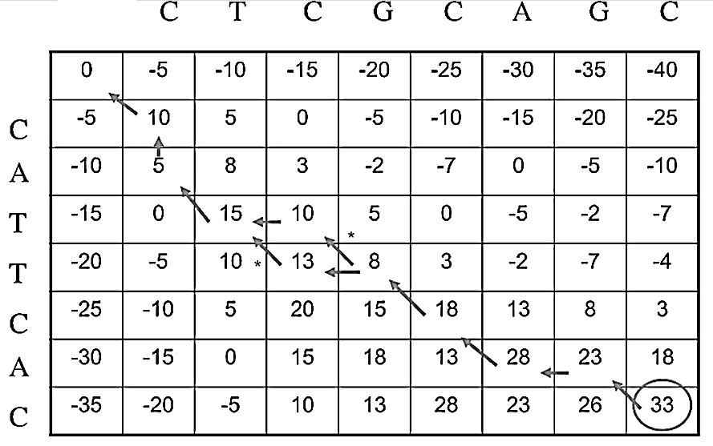

Ans: Alignment_1- CAT_TCA_C , Alignment_2- CATT_CA_C
C_TCGCAGC C_TCGCAGC

- Use the following multiple protein sequence alignment layout, and answer the following questions:
PQPP a) Calculate P(P), P(Q) P(P) = 0.55, P(Q) = 0.45 (6 marks)
QQPQ b) Calculate ePQ P(P)*P(Q) = 0.25
PPQP c) Calculate qPQ qPQ = 0.50
QQPP d) Compute lod(P→Q) = 1
PQQP e) Also compute lod(Q→P). Which substitution is more favored – P→Q or Q→P?
Ans: lod(Q→P) = lod(P→Q) is 1 bits (symmetric) so equally favored.

- You are given the following 4 DNA sequences (aligned, length = 8) for creating a phylogenetic tree.
Seq1: ATGCTTAC
Seq2: ATGCGTAC
Seq3: ATCCGTAT
Seq4: TTGCGTAC

- Construct a pairwise distance matrix for these four taxa. (2 marks)
- For each taxon, calculate the net divergence (sum of its distances to all other taxa). Use these values to transform the distance matrix, as required for the Neighbor Joining method. Now use this transformed matrix to identify the pair of taxa that should be clustered into the first clade. Show the updated tree topology after this first joining step, including the calculated branch lengths. (6 marks)
Ans:
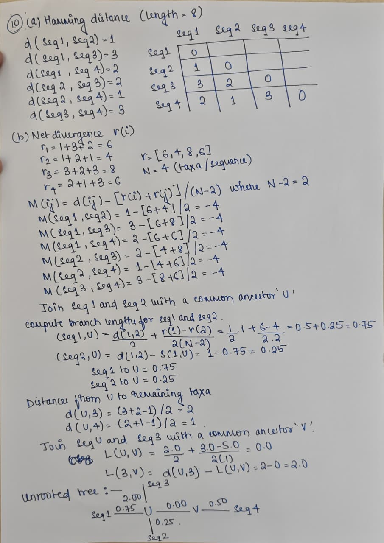

When sequence 1 and 2 are joined by the common ancestor 'U', the distance S1(1,U) is 1.0 and not 0.75. The mistake occurs because (6-4)/(2.2) is taken as 0.25, but it should be 0.5, which makes the entire sum 1.0 and not 0.75.

- Draw the phylogenetic tree that corresponds to (ant:17, (bat:31, cow:22):7, dog:22, (elk:33, fox:12):40). Is this a rooted or an unrooted tree? (4 marks)
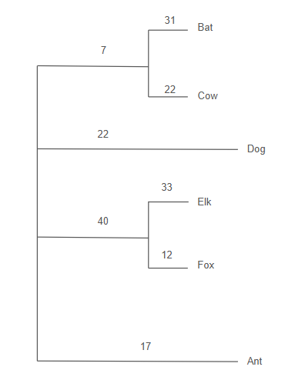
Ans : Unrooted Tree

- Align the given two reads to make a contiguous sequence (contig) using dynamic programming approach. (10 marks)
R1: ATTCGCGAG R2: GGCGAGCTCA
Scoring scheme: Match = +2, Mismatch = -1, Gap = -2
Ans:
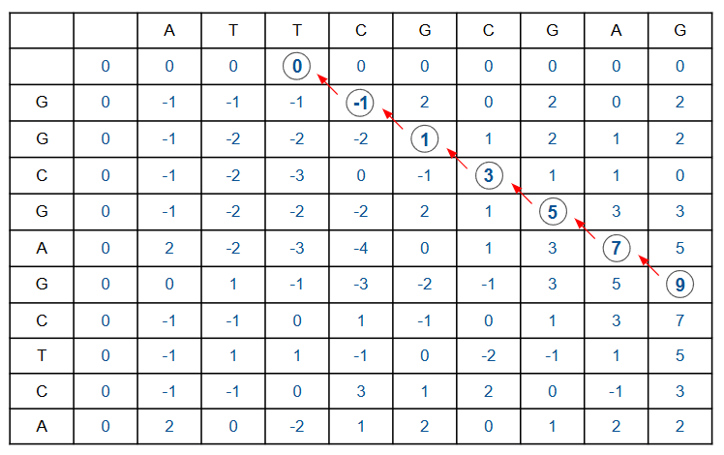
ATTCGCGAG_ _ _
_ _ _GGCGAG_ _ _

